**Lab 0 – Configure your Virtual Box Environment**

1. **Set up two VBox Network Adapters as follows:**

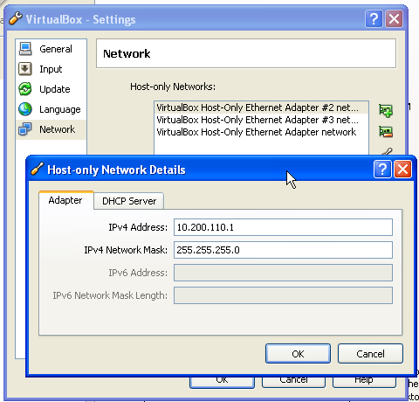

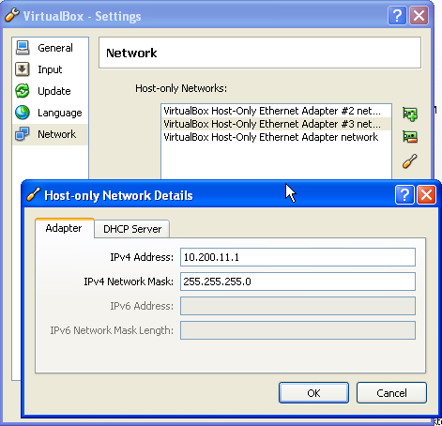

No DHCP Server necessary.

You may get an error when you create the adapters! We have found that they get created anyway. Exit the ‘Preferences’ dialog and re-enter and you should see each adapter after the Error on create. Also, go to ‘My Network Places’ 🡪 ‘View Network Connections’ and you should see them as ‘Connected’.

1. **Create the Windows Guest Image**
   1. In VBox, click on New (to create a new virtual machine)
   2. NAME: WINCLIENT, Operating System: Microsoft Windows,

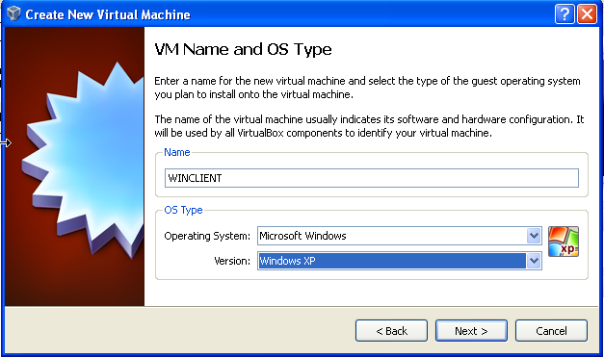

* 1. Memory: 512MB

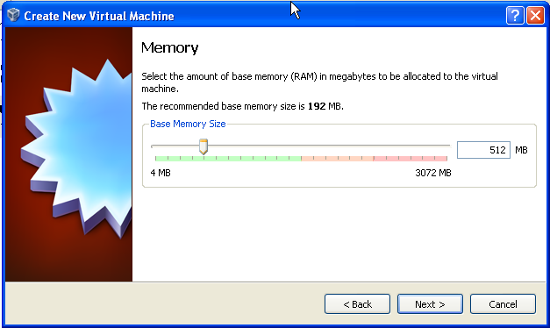

* 1. Use existing Hard Disk:

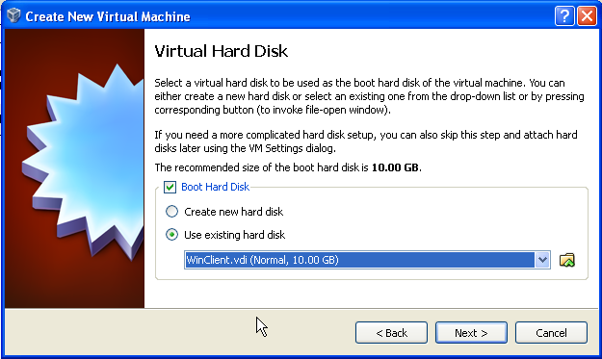

* 1. Click Finish
  2. Click on Settings, Network. Set Adapter 1 to Bridged, click O K
  3. Set Adapter 2 to Host-Only Ethernet Adapter #3:

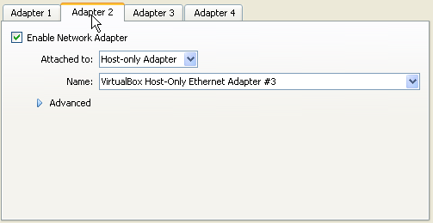

* 1. The Windows client will be used to run SQL Plus and all scripts to the Oracle database and the Oracle Database Firewall Analyzer. It should have the following IP address: 10.200.11.55. Start up the image and check now, or continue configuration of the other boxes and check later.

1. Create the Database Guest Image
   1. In VBox, click on New (to create a new virtual machine)
   2. NAME: DBSEC, Operating System: Linux, Oracle

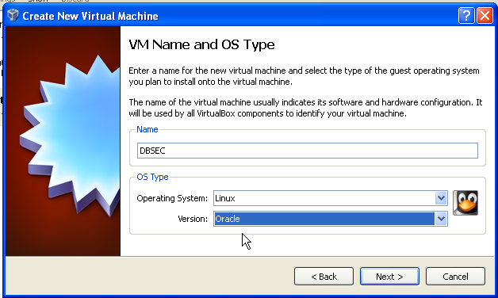

* 1. Memory: 1024 MB
  2. Use Existing hard disk 

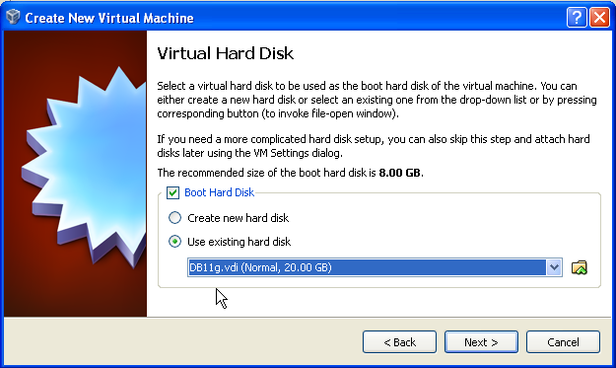

* 1. Click Finish
  2. Click on Settings, Network. Set to Host-Only Ethernet Adapter #2

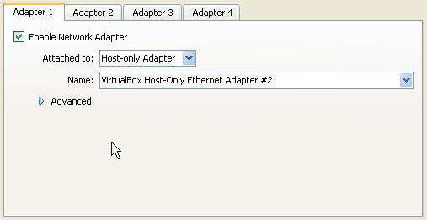

* 1. **Only configure Adapter 1. Hardcoded IP for the Linux database server -- 10.200.11.205**
     + Startup the Database Host.
     + Login to OEL Host: oracle/oracle
     + Confirm the network settings for eth0:
       1. Pick System 🡪 Administration 🡪 Network

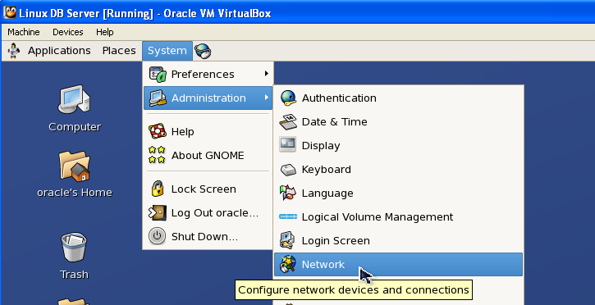

* + - 1. Enter the password for root: oracle

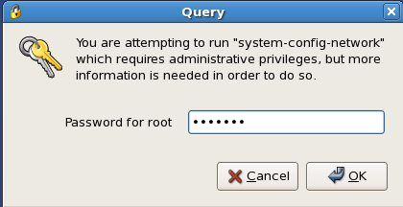

* + - 1. You may see two Ethernet adapters. Just ignore the second (you can even delete it if you like). Select eth0, then Edit:

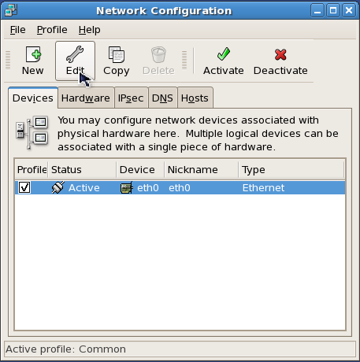

* + - 1. Set the static IP address as below (no gateway is needed):

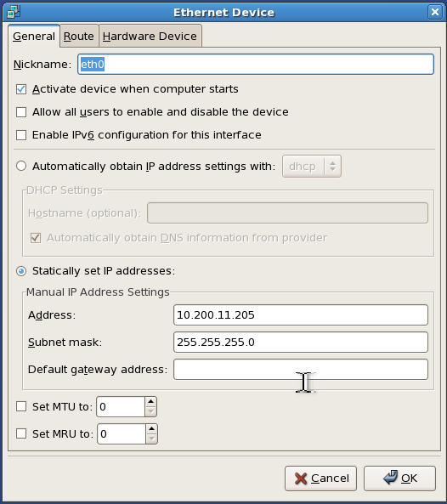

* + - Hit OK. Then, enable the device. (or Disable and Enable if already active). You will get prompted as to whether you want to save your configuration. Of course you do.

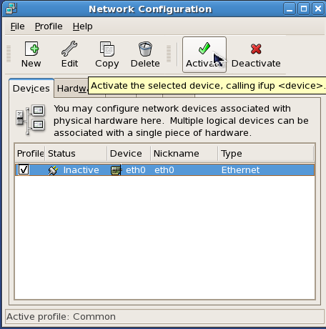

* 1. An Oracle 11.2.0.1 database ha s been installed on this VBox running OEL 5.4.
  2. To start up the database and listener, click on the Database Firewall Folder on the Desktop, click on Start DB01

1. Create Database Firewall Virtual Machine
2. Click on New to create a new Virtual Machine
3. Click on Next on the Welcome Screen
4. Enter a name, such as DBFW

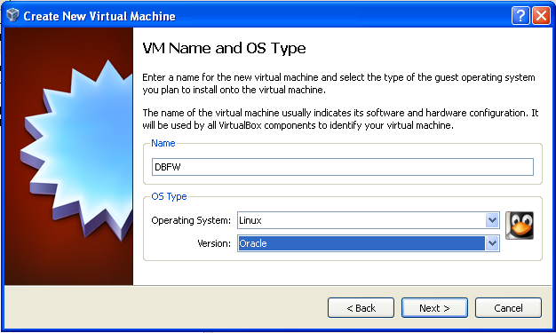

1. Set the base memory size to 1024. This can later be reduced to 512MB but must be a minimum of 1024 at install time or the installation will fail. Click on Next

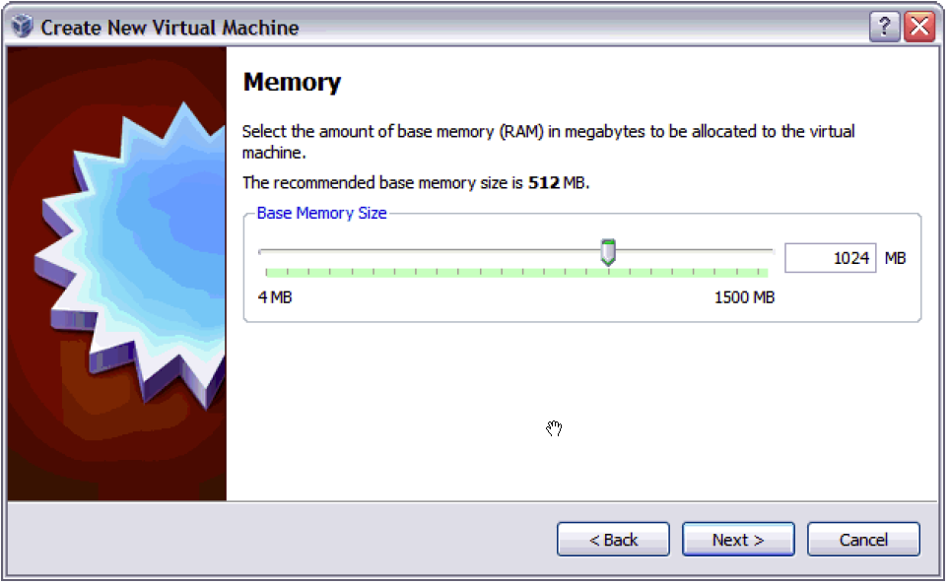

1. For Virtual Hard Disk, accept the default of ‘Create New Hard Disk’. Ensure Boot Hard Disk is selected.

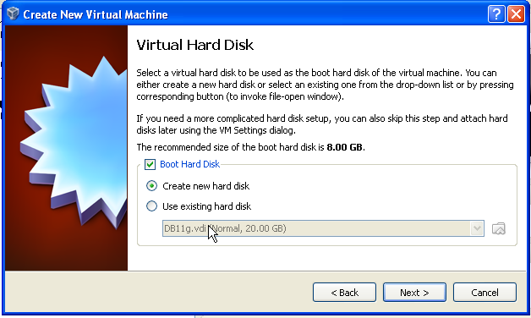

1. Click Next on the ‘Welcome to the Create New Virtual Disk Wizard’ screen.
2. Accept the default setting of ‘Dynamically Expanding Storage’ and click Next.

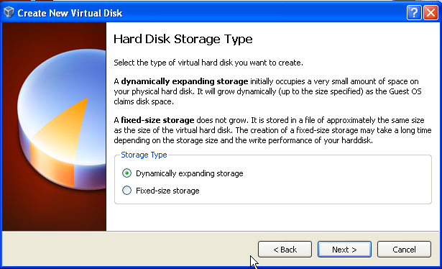

1. Click on the Browse icon and select a location for the Virtual Machine disk image file. Set the maximum disk image size to 80GB. If you set it to a value less than 70GB, the installation will fail. The virtual disk file will use less than 4GB (for now) as long as you selected Dynamically Expanding Storage.

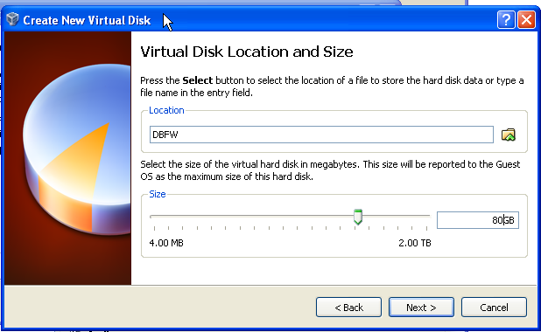

1. Click Finish on the Summary Screen.
2. Click Finish on the ‘Create New Virtual Machine’ Summary screen.

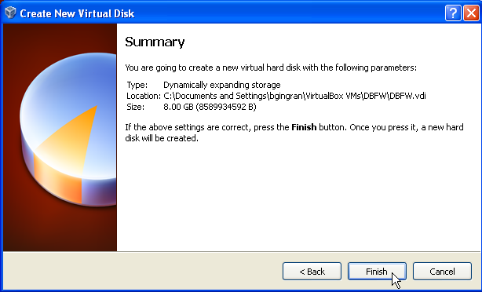

1. With the icon for the new VM selected, click on Settings.
2. On the Settings screen, click on System, click on Processor. Set it to 2 CPUs Check the Extended Features: Enable PAE/NX

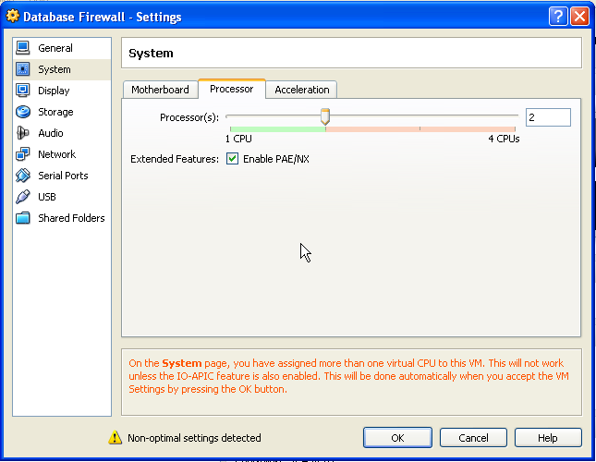

1. Configure THREE network adapters – 3-2-3, as follows. This step is critical**:**

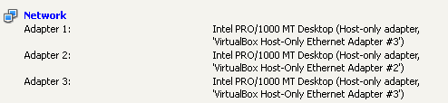

**You are now ready to install Database Firewall!!**